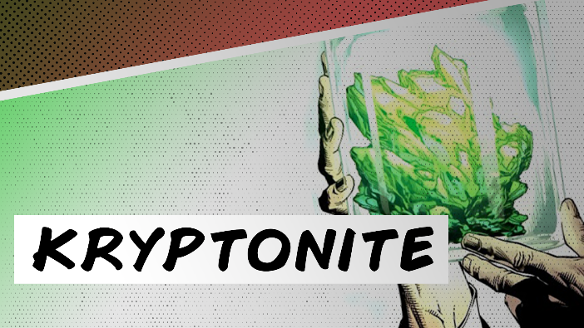
Handout

Week 6: Keeping Our
Relationships from Unraveling
May 16, 2021

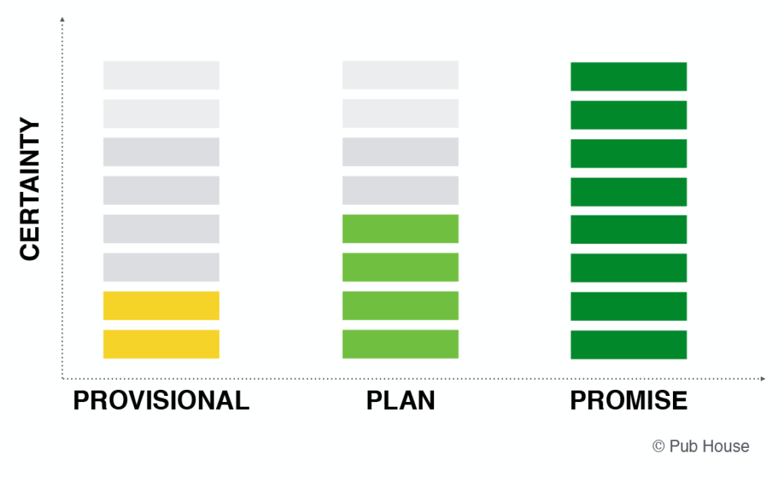
Provisional/Plan/Promise

